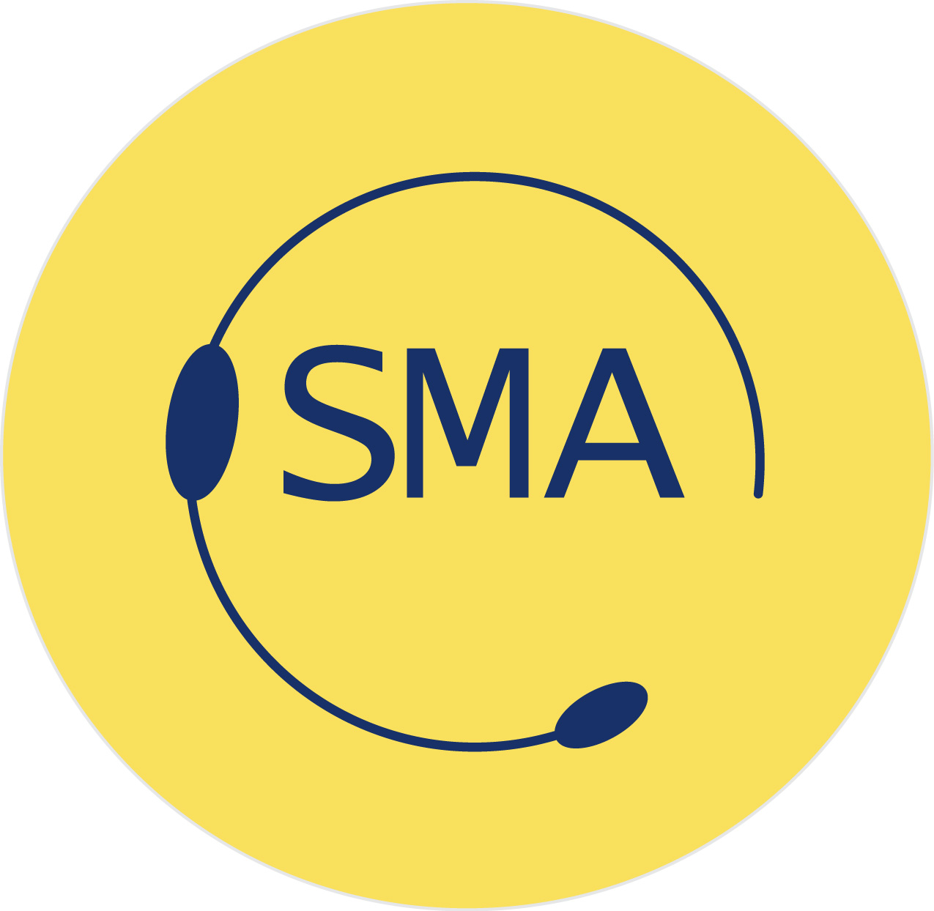

PROFESSIONAL

Do you work as a PROFESSIONAL STAGE MANAGER

in Theatre, Events, Television or Education?
For information on what SMA Membership can do for you, read on:

1: What does it offer?
HELP FINDING WORK in four key ways:
- The SMA Freelist: The only listing that shows prospective employers exactly when you are available; produced monthly and emailed out initially to over 700 potential employers it is updated daily and available on request and for other SMA Members to download from the SMA Website. The Freelist is provided FREE to the industry.
- FREE full entry on SPOTLIGHT: Spotlight is not just for actors, it has a dedicated stage management section only for SMA Members. Potential employers who have a Spotlight account can view your full CV. You have access to your details to update as necessary. Your Spotlight Membership Card also provides you with many special offers.
- Mandy.com Premium Membership 25% discount: Whilst you can list yourself on Mandy for free, to access the job details in full requires Premium Membership.
- SMA Website: Constantly updated jobs listings only available for SMA Members.

INFORMATION: Read up on issues and news relevant to stage management or hunt for digs and advice in our newsletter CUELINE or on our website members’ area. The SMA also produces a roundup email, Agenda every Tuesday which contains new and interesting information and publishes factsheets and guides available FREE to all our members.

NETWORKING & EVENTS!! Meet fellow stage managers and share your experiences at our regular member events including exclusive backstage tours and seminars.

CAREER DEVELOPMENT AND TRAINING: The SMA offers help & advice and a range of practical courses run by working professionals at discounted rates for members. Courses cover Company Management, Production Management, Cueing from Music/Scorereading, Relighting, Health & Safety, Event Management, Props, Automation and much, much more.

PRACTICAL ADVICE: The SMA was formed by stage managers for stage managers. We know the problems you may encounter and can offer advice or simply someone to talk to. If we don’t know the answer, we know a member who does.

REPRESENTATION: The SMA is the only body in the UK exclusively representing stage management. We can take your concerns to the right people; make your voice heard and give it the weight of your many colleagues. The SMA raises the profile of stage management and the issues that affect it.

2. Who is eligible?
Anyone who has worked on the stage management staff of a professional company in the UK and whose application is approved by the SMA Board of Directors. Two professional references are required one of whom must be a SMA Professional Member. Graduate members upgrade with just one reference

3. What do I need to do now?
You can find more information and apply here:

APPLICATION: PROFESSIONAL MEMBERSHIP

Professional name (m/f)
Permanent address

Date of birth
Phone number
Email address
Training (if any)
PROFESSIONAL APPLICATIONS: Referee name(s) and email addresses please
Two referees required who both know your professional stage management work.
Ideally one would be a SMA Professional Member. (contact us for help and advice)
Graduates upgrading need only 1 reference
Referee 1- Name
Contact: email and phone
Referee 2 -Name
Contact: email and phone
Introduced by
Record of work | Please attach a current CV or details of recent work

WAYS TO PAY THE SMA:
- Online from the website (members use your home page)
- Direct via Stripe or website Pay the SMA | Stage Management Association Members use your home page
- Online banking (BACS): In the ‘reference’ box please put the name we know you by, so we can match the payment to you!

Please tick the amount and method of payment in the correct box below:

e- Member Receive no postal mailouts, including:no hardcopy of the SMA
Cueline quarterly magazine – read it as PDF online instead
Print member receives 2 copies per year of Cueline by post
E PROFESSIONAL | £93 + £15 joining fee |  |  | TOTAL: £108
PROFESSIONAL | £120 + £15 join fee |  |  | TOTAL: £135
Cheque enclosed
Paid by card via SMA Website |  |  |  | Date:
Paid by online banking (BACS) |  |  |  | Date:
SMA Address  Stage Management Association  Bishopsgate Institute, 230 Bishopsgate, London EC2M 4QH  E: admin@stagemanagementassociation.co.uk |  | SMA Bank Account Details  Bank: HSBC  Stage Management Association  Sort Code : 40-11-58  Account Number: 80312010

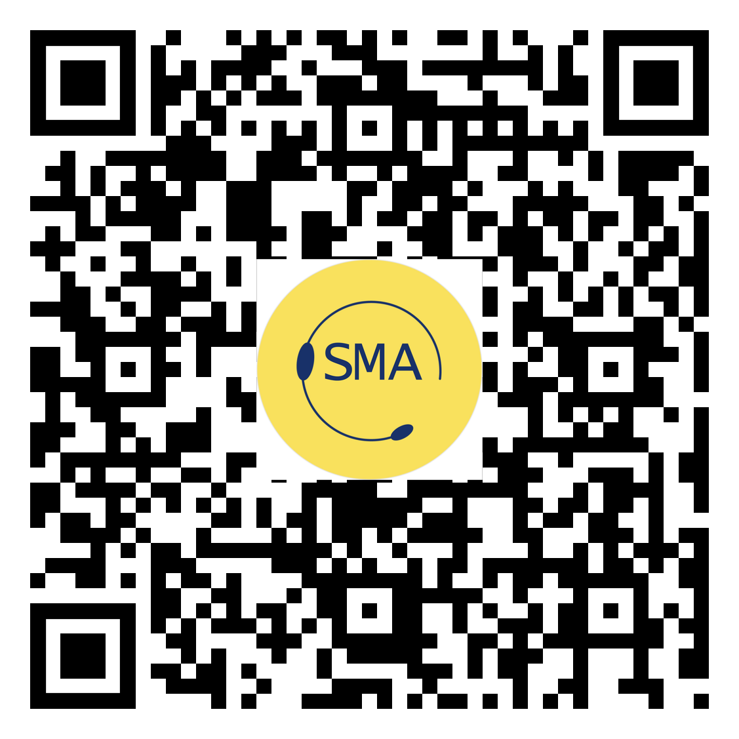

admin@stagemanagementassociation.co.uk
@SMAssoc
www.stagemanagementassociation.co.uk

